OPTI CROP ER DIAGRAM

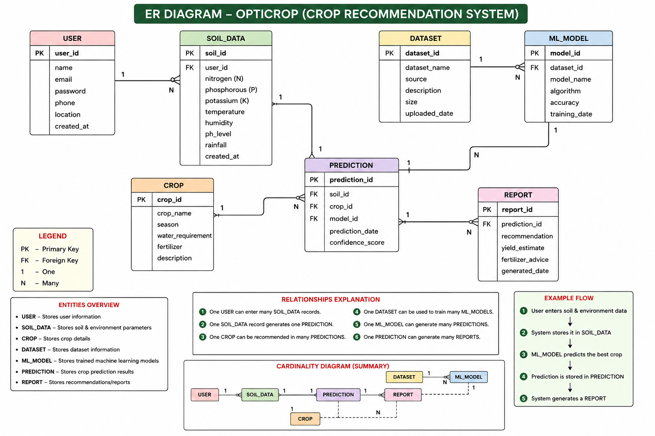
Entity Relationship (ER) Diagram
The Entity Relationship (ER) Diagram represents the database structure of the AI-Based Crop Recommendation System. It illustrates the entities involved in the system, their attributes, and the relationships between them. The database is designed to efficiently store soil information, crop details, machine learning datasets, prediction results, and generated reports.
Entities Description
1. User
The User entity stores the details of farmers or users who interact with the system. Users provide soil information and request crop recommendations.
Attributes
- User_ID (Primary Key)
- Name
- Email
- Password
- Mobile_Number

2. SoilData
The SoilData entity stores the soil parameters entered by the user. These values are used as input for the machine learning model.
Attributes
- Soil_ID (Primary Key)
- User_ID (Foreign Key)
- Nitrogen (N)
- Phosphorus (P)
- Potassium (K)
- Temperature
- Humidity
- pH
- Rainfall

3. Crop
The Crop entity contains information about the crops that can be recommended by the system.
Attributes
- Crop_ID (Primary Key)
- Crop_Name
- Season
- Description

4. Dataset
The Dataset entity stores the training dataset used to train the machine learning model.
Attributes
- Dataset_ID (Primary Key)
- Dataset_Name
- Source
- Total_Records
- Features

5. MLModel
The MLModel entity represents the trained machine learning model used for crop prediction.
Attributes
- Model_ID (Primary Key)
- Model_Name
- Algorithm
- Accuracy
- Training_Date

6. Prediction
The Prediction entity stores the prediction generated by the trained model for a user's soil data.
Attributes
- Prediction_ID (Primary Key)
- Soil_ID (Foreign Key)
- Crop_ID (Foreign Key)
- Model_ID (Foreign Key)
- Prediction_Date
- Confidence_Score

7. Report
The Report entity stores the prediction reports generated for users.
Attributes
- Report_ID (Primary Key)
- Prediction_ID (Foreign Key)
- User_ID (Foreign Key)
- Generated_Date
- Report_Status

Relationships
Relationship | Description
User → SoilData (1:N) | One user can submit multiple soil records, but each soil record belongs to only one user.
SoilData → Prediction (1:1) | Each soil record generates one prediction.
Crop → Prediction (1:N) | One crop can appear in many prediction results, while each prediction recommends one crop.
Dataset → MLModel (1:N) | One dataset can be used to train multiple machine learning models.
MLModel → Prediction (1:N) | One machine learning model can generate multiple predictions.
Prediction → Report (1:1) | Every prediction produces one report.
User → Report (1:N) | A user can have multiple generated reports over time.

Working of the ER Diagram
- The User registers and logs into the system.
- The user enters soil parameters, which are stored in the SoilData entity.
- The MLModel, trained using the Dataset, processes the soil information.
- The system predicts the most suitable Crop for cultivation.
- The prediction details are stored in the Prediction entity.
- Finally, a detailed recommendation is generated and stored in the Report entity for future reference.

Overall Description
The ER Diagram provides a clear representation of how data flows within the Crop Recommendation System. It demonstrates the interaction between users, soil information, machine learning models, crop recommendations, and generated reports. The relationships ensure data integrity by connecting related entities through primary and foreign keys, enabling efficient storage, retrieval, and management of agricultural prediction data. This database design supports accurate crop recommendations while maintaining organized records of users, predictions, and reports.

